**Autumn 2023 Algae Panel Project - Code Functionality Notes**

Working:

* Infrared Receiver (IR) works with Remote Control for menu navigation.
* Solenoid Valve turns ON and OFF via Remote Control.
* Pump turns ON and OFF via Remote Control.
* Temperature Sensors show correct water temperature (data wire connected to pins 12 and 13 of the Arduino Mega).

Untested (but should work):

* Ultrasonic Sensor should work with the Yellow/Blue Cable (TX) connected to Pin 14 and the White/Green Cable (RX) connected to Pin 15 of the Arduino Mega, however **untested**.

Not currently working:

* LCD is unreliable. Potential fix:
  + Connect 4.7k – 10k pull-up resistors between the SDA + SCL lines and 5V. See circuit diagram below:

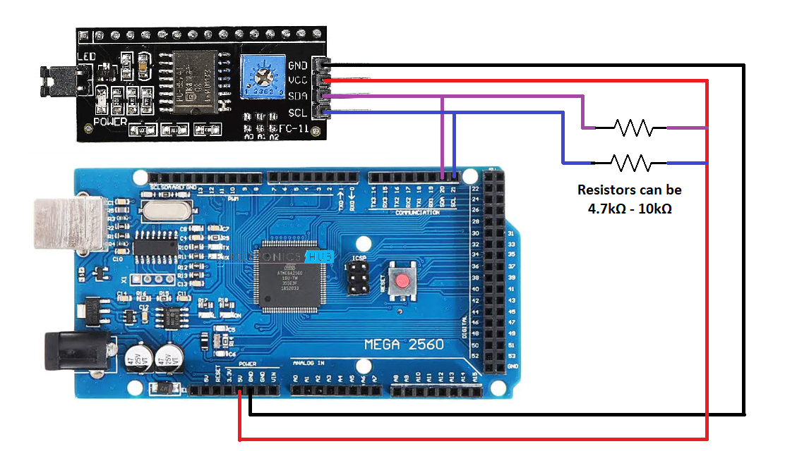

* No current working sensor to detect water level of **panel**:
  + Waterproof Ultrasonic Sensor (A02YYUW – same one as used in the Esky/Reservoir) does not physically fit in the panel.
  + Non-waterproof Ultrasonic Sensor (HC-SR04) unreliable – due to panel width being small, was very common for sensor to return a distance from the glass rather than the water surface.
  + **Potential solutions:**
    - IR Distance Sensor: Uses laser to get distance to a reflective surface. **Problem:** Water commonly doesn’t reflect the beam. In testing, the distance would sometimes measure the water surface, but would also sometimes measure through the water to the bottom, making it unreliable.
    - Float Switch: These will not indicate the level of the water but will act as a trigger if the water level gets too high, which can be used logically to turn off the pump and/or turn on the solenoid valve to help prevent overflow.

Unwritten:

* Currently no code in the main program to integrate temperature levels with pump + valve operation. This could be added as such:
  + // If temperature above threshold and Solenoid Valve is currently OFF, turn it ON.  
    if(SolenoidState == Control_State::Off && Temp1Average >= MAX_THRESHOLD)  
    {  
     SolenoidState = Control_State::Manual; // Turn on Solenoid Valve

}

// Else if temperature is below threshold and the Solenoid Valve is ON, turn it OFF

else if(SolenoidState == Control_State::Manual && Temp1Average < MAX_THRESHOLD)

{

SolenoidState = Control_State::Off; // Turn off Solenoid Valve

}

// If temperature above threshold and pump is ON, turn it OFF

if(PumpState == Control_State::Manual && Temp1Average >= MAX_THRESHOLD)  
{  
 PumpController.setPwmEnable(PWM_DISENABLE); // Turn off Pump Controller

}

// Else if temperature is below threshold, and there is water in the reservoir, and the pump is OFF, turn it ON

else if(PumpState == Control_State::Off && SonarAverage < DEPTH_THRESHOLD && Temp1Average < MAX_THRESHOLD)

{

PumpController.setPwmEnable(PWM_ENABLE); // Turn on Pump Controller

}

* Currently no code integrating level of reservoir with pump control. This could be added as such:
  + // If distance from sensor to reservoir water level is greater than some threshold, turn off pump (not enough water in reservoir)

if(SonarAverage > DEPTH_THRESHOLD && PumpState == Control_State::Manual)

{

PumpController.setPwmEnable(PWM_DISENABLE); // Turn on Pump Controller

}